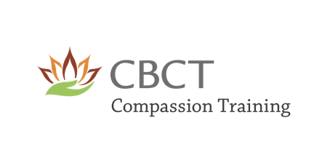

***Registration form to apply for the Course***

To be completed before paying the fee or receiving discounts/scholarships

**1) Today’s date (submittal date):**

**2) Name and Surname:**

**3) Preferred Email address:**

**4) Preferred Phone number:**

**5) Short Bio:**

**6) Short Personal statement on why are you interested in the course:**

**7) List some previous experience on the studies and practices of compassion if there is any:**

**8) Start Date and Time of the course you would like to take:**

**9) Specify the modality (online or in presence):**

**10) Have you completed and signed the liability waiver?**

(You should do it at the same time of completing this registration form to be able to move forward with the application)

**11) Are you interested in discounts/partial or full scholarships (please specify)?**

We will send you the confirmation, instructions for payment and other important information needed to start the course with us very soon.

Thank you,

**Center for Contemplative Science and Compassion-Based Ethics at Emory University 1599 Clifton Rd. NE, Atlanta, GA 30322**